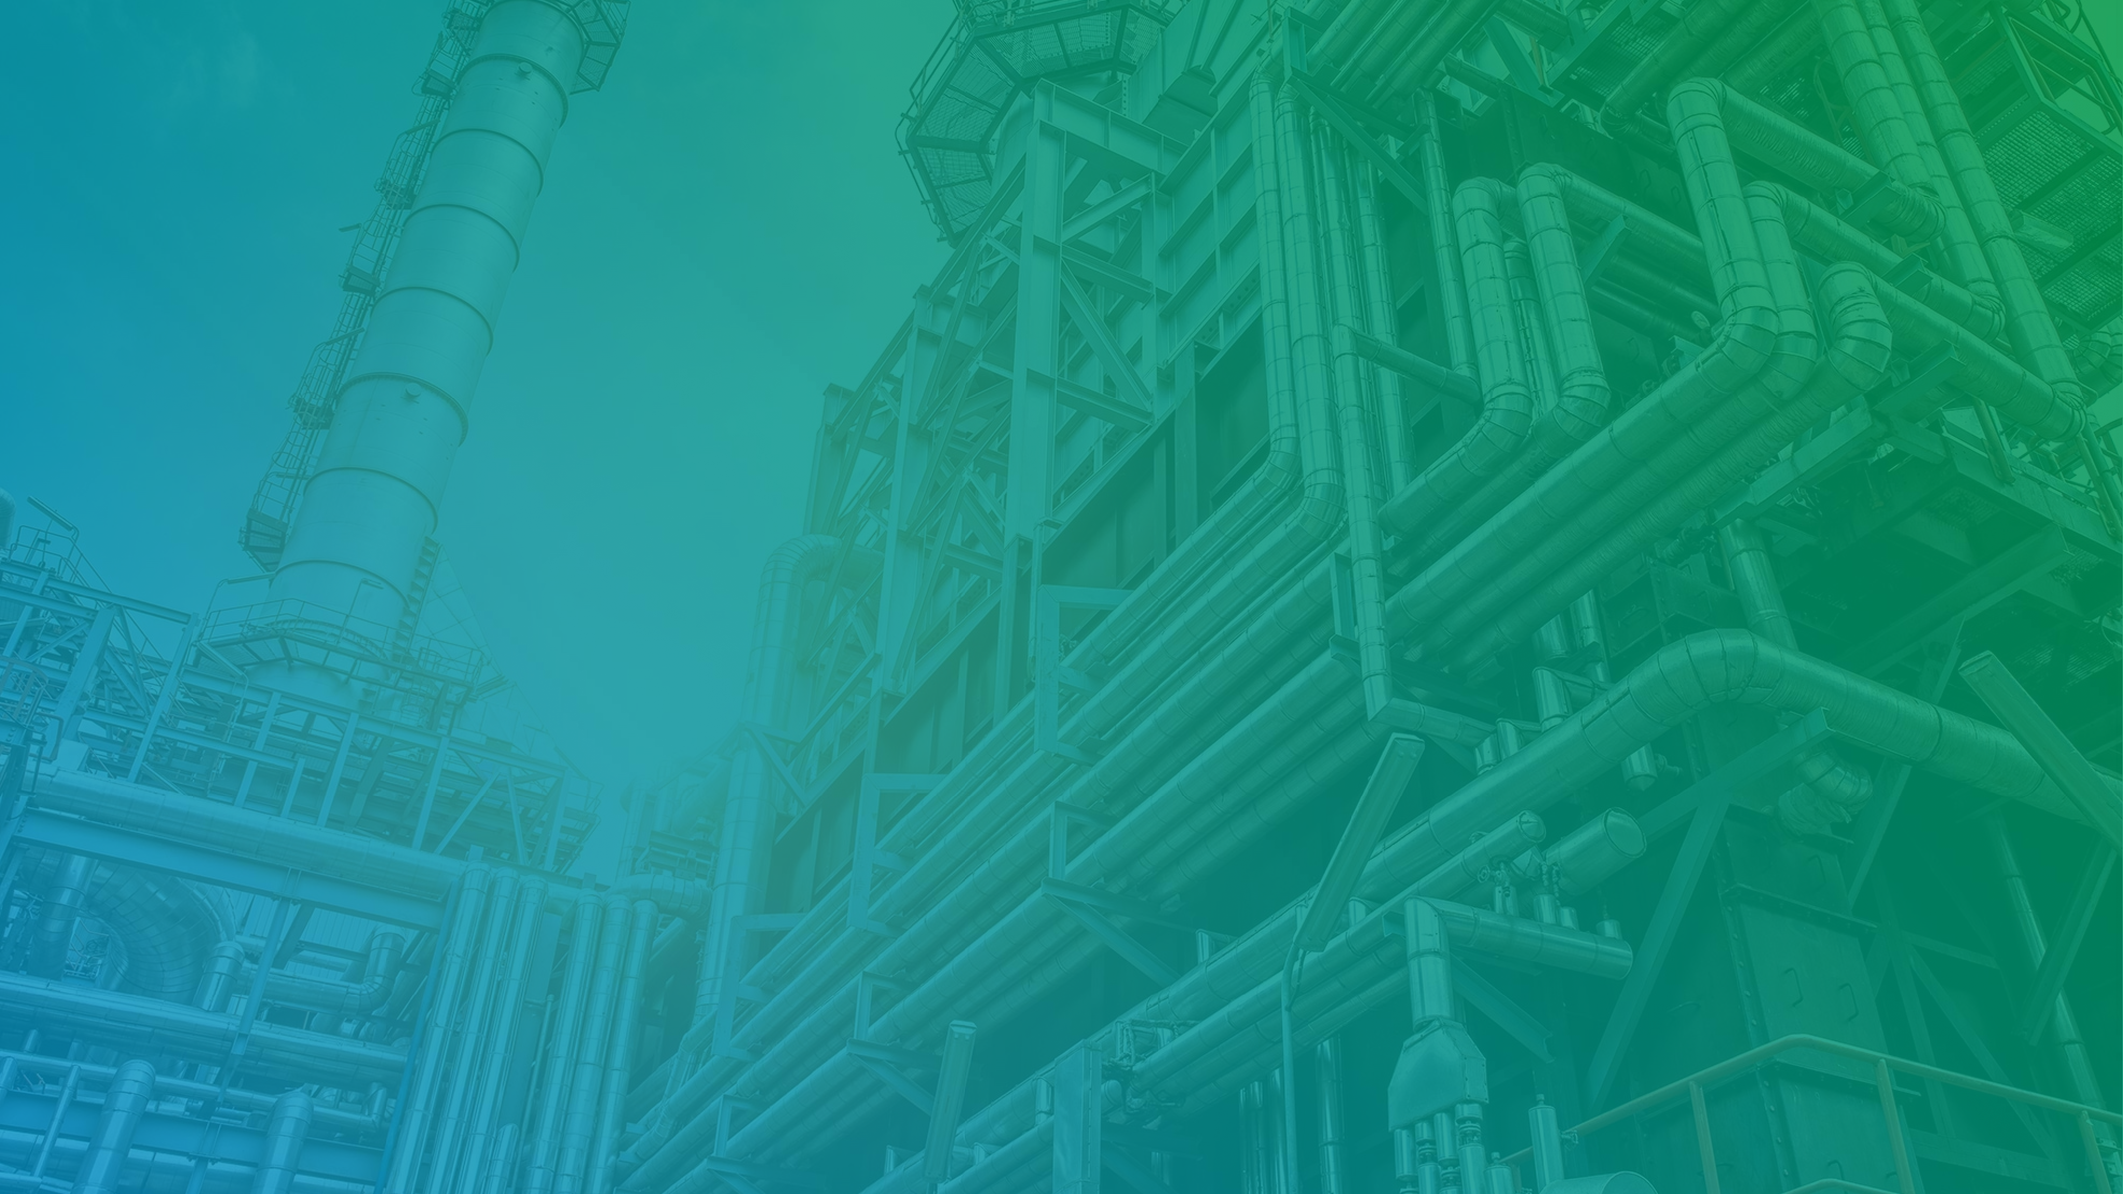

OAISIS Alcohol India Pvt Ltd

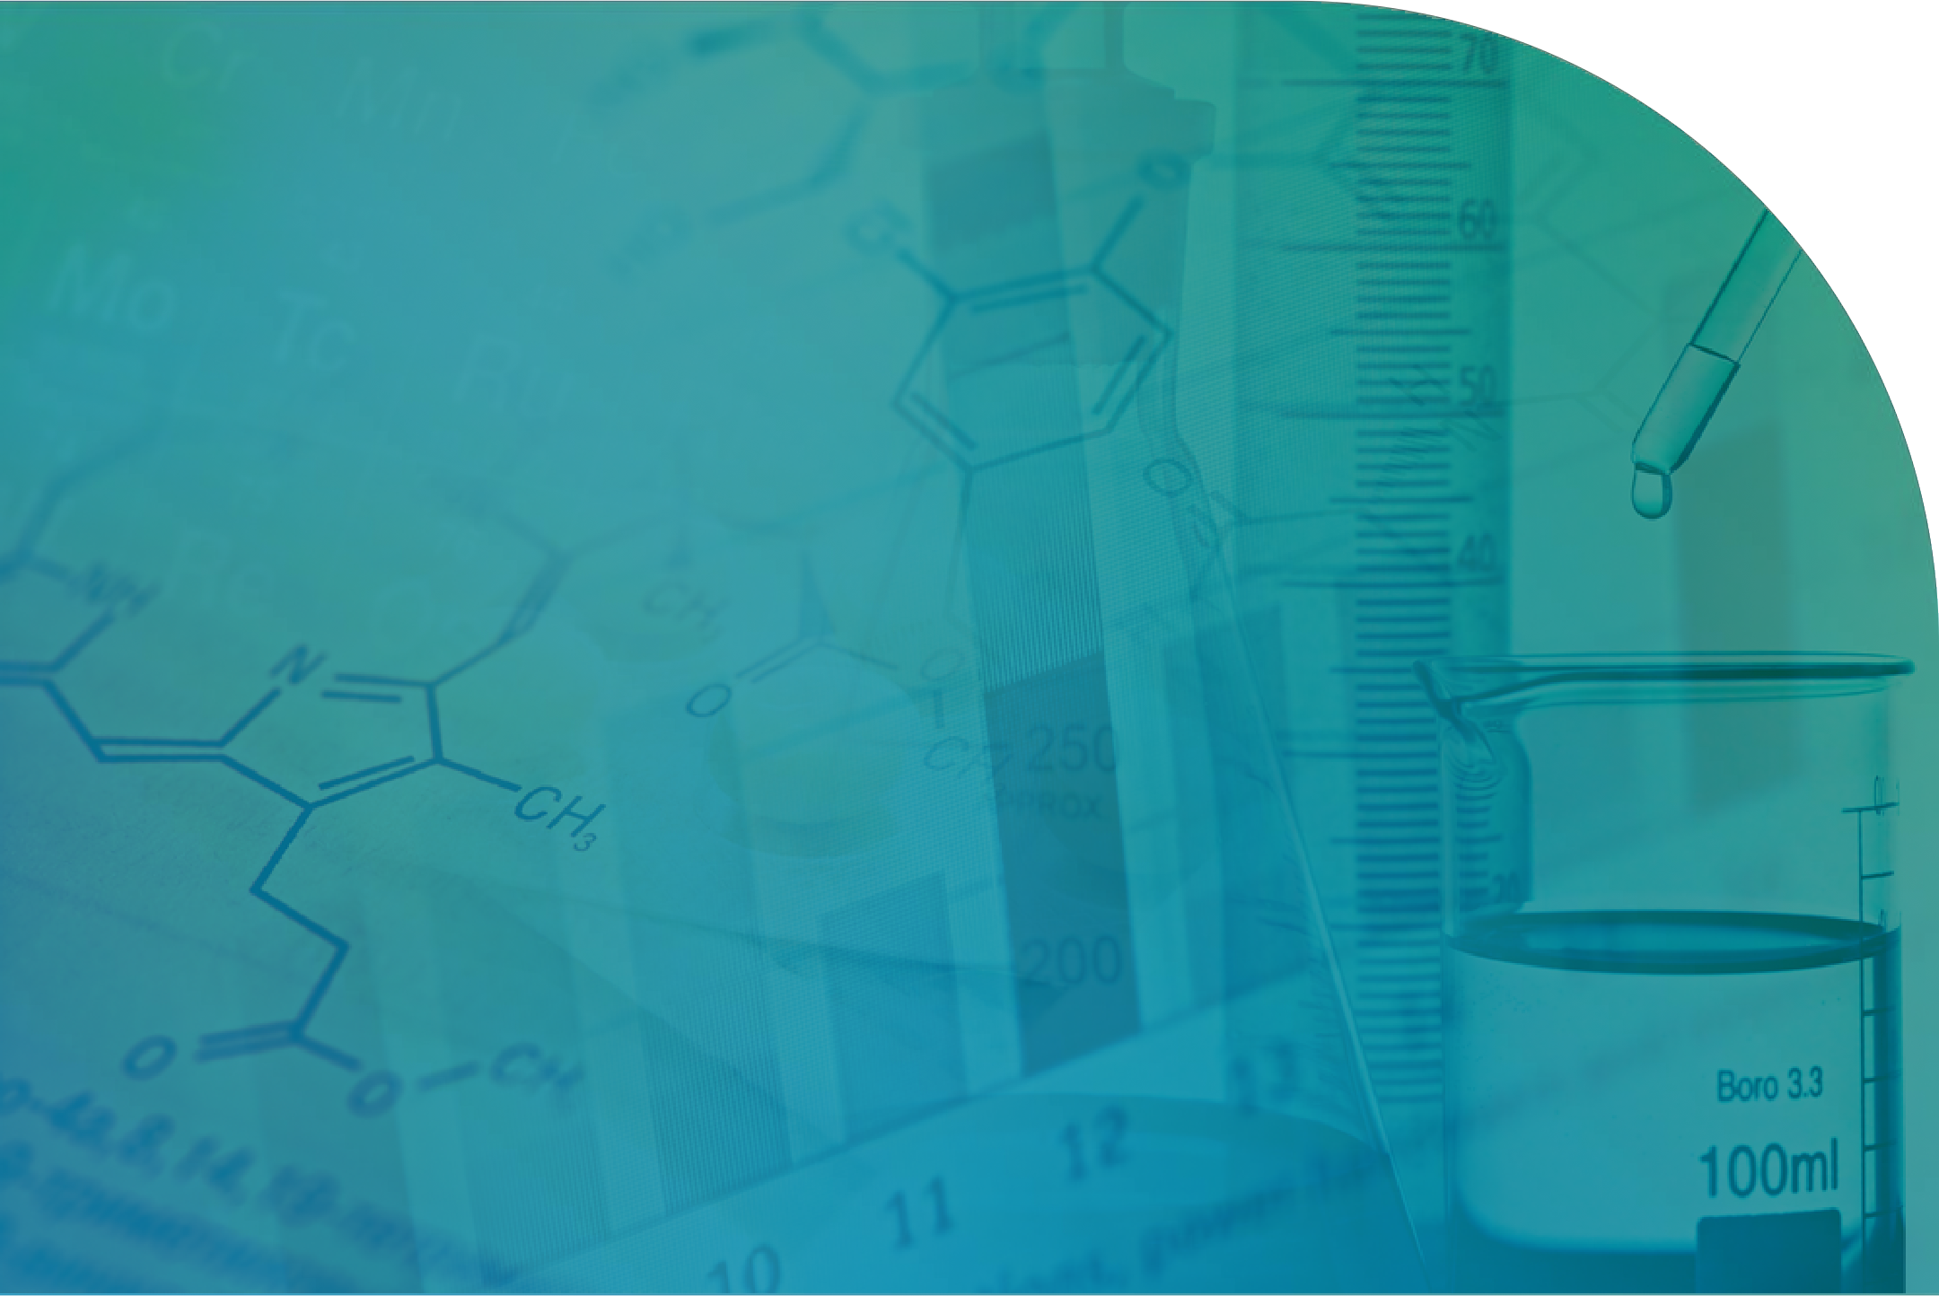About Us Products Plants Machineries

INDEX
Laboratory Instruments Warehouse
Distribution System Licenses

Oaisis Alcohol (India) Pvt Ltd














































Products


Ethanol
Alcohol







Plant

Karad, Maharashtra

MFG Process, Lab Details, Warehouse

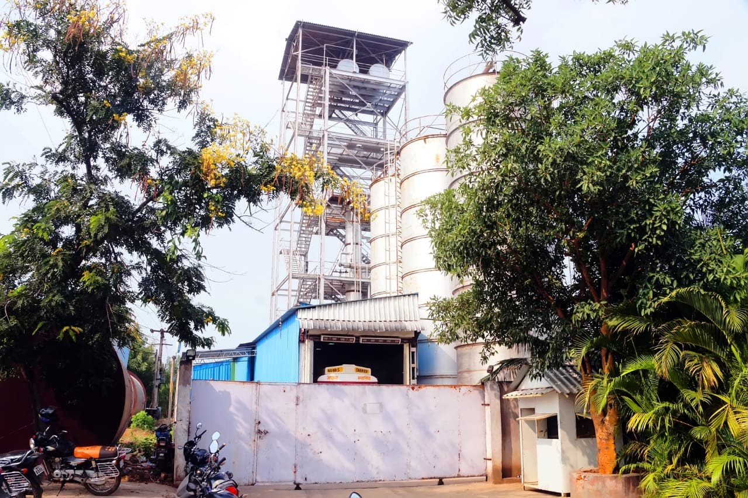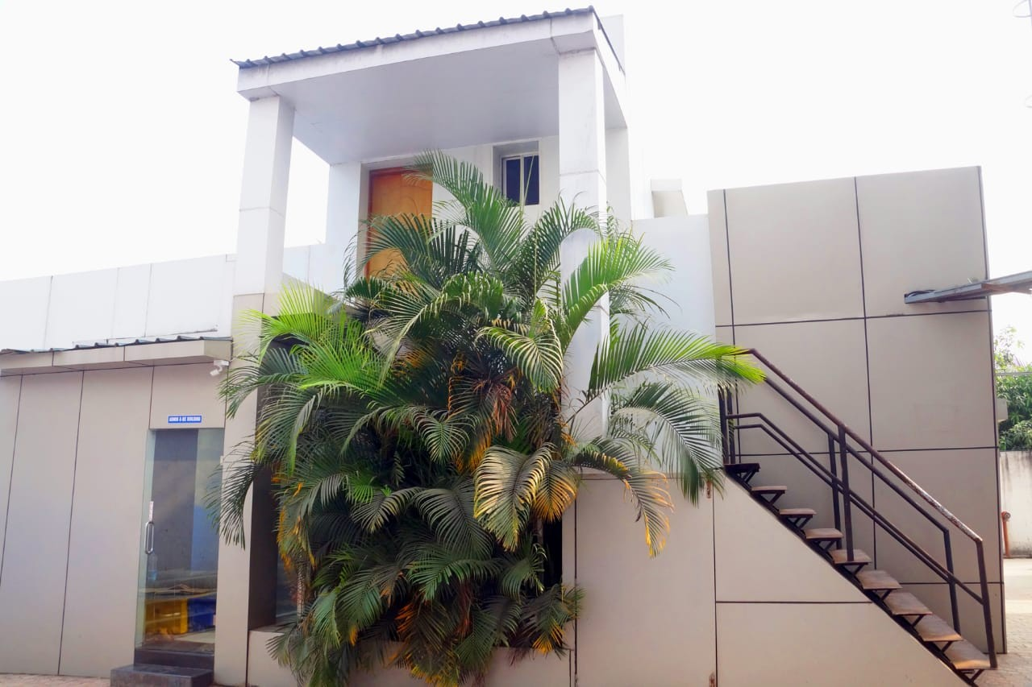

Plant

Karad, Maharashtra

MFG Process, Lab Details, Warehouse

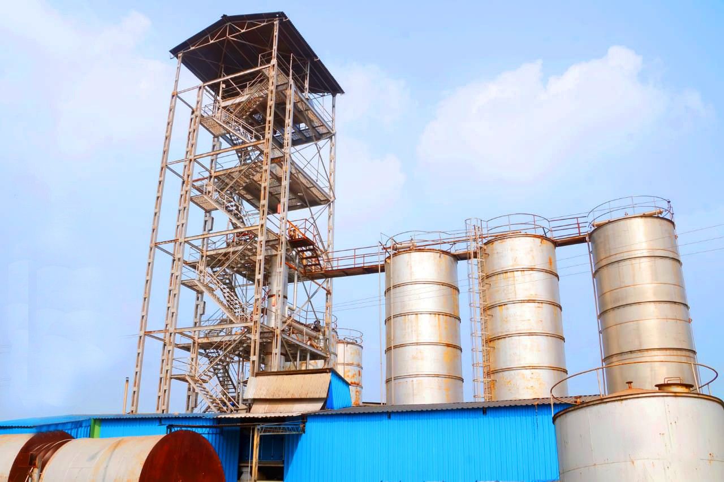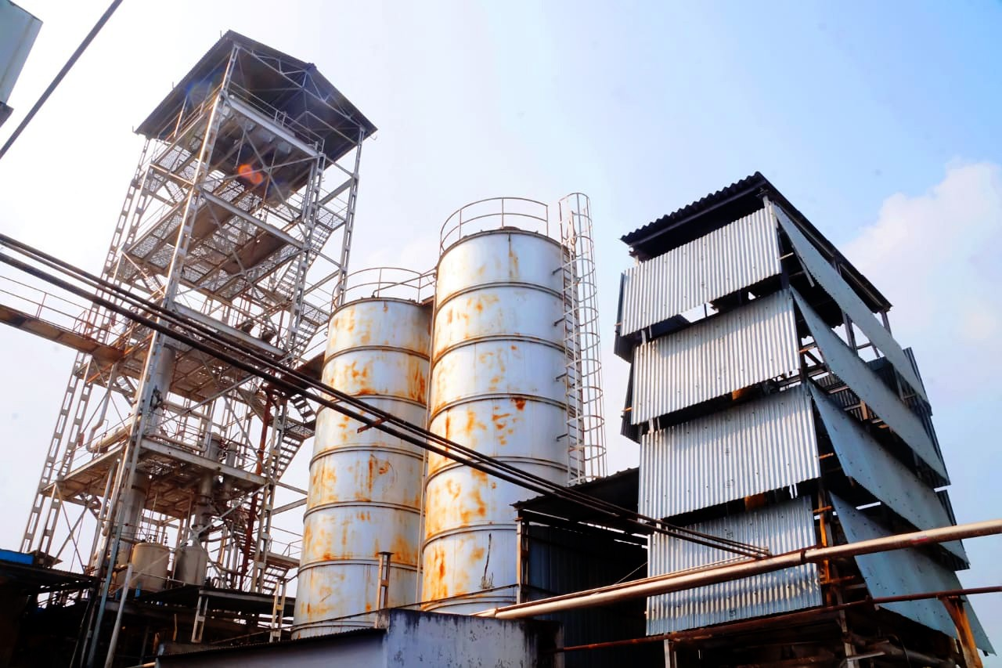

Plant

Karad, Maharashtra

MFG Process, Lab Details, Warehouse

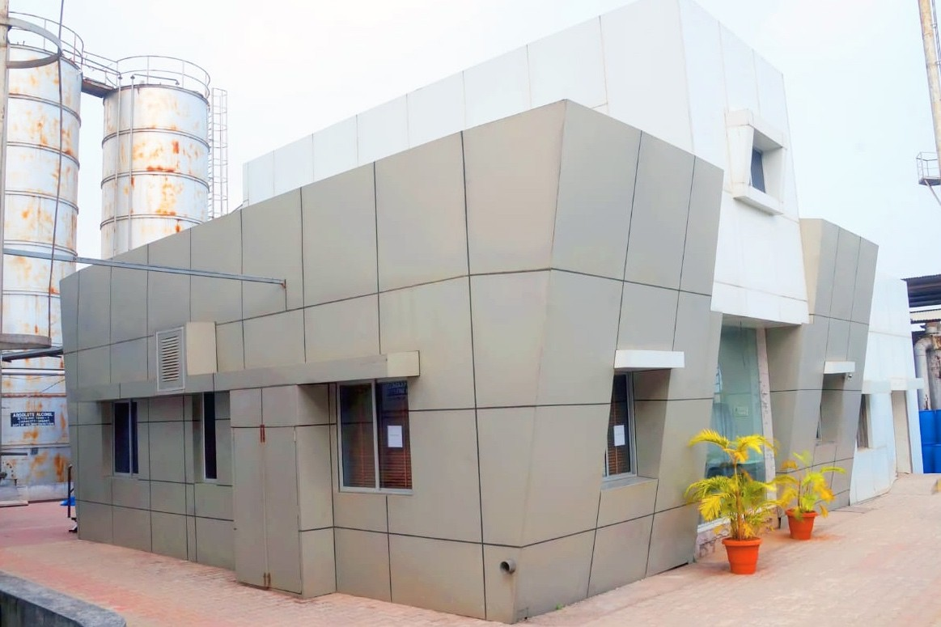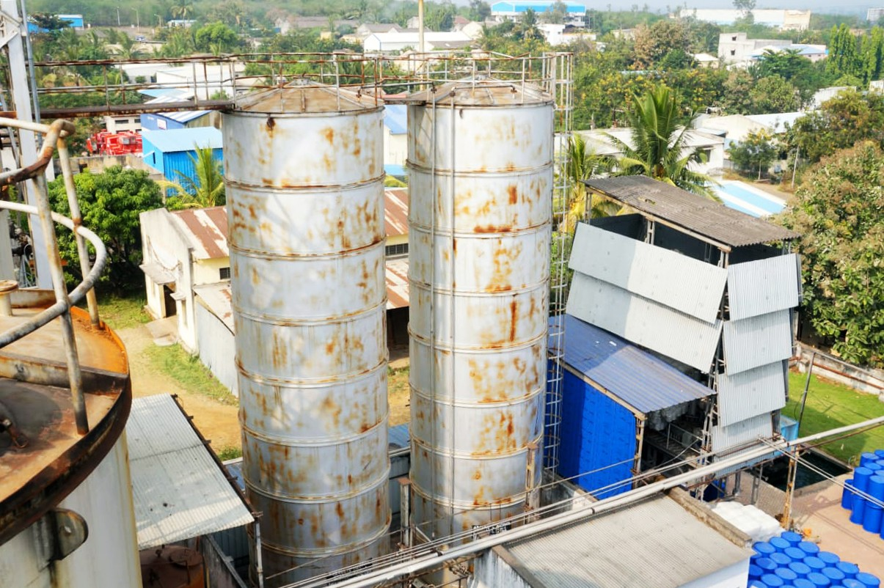

Plant

Karad, Maharashtra

MFG Process, Lab Details, Warehouse

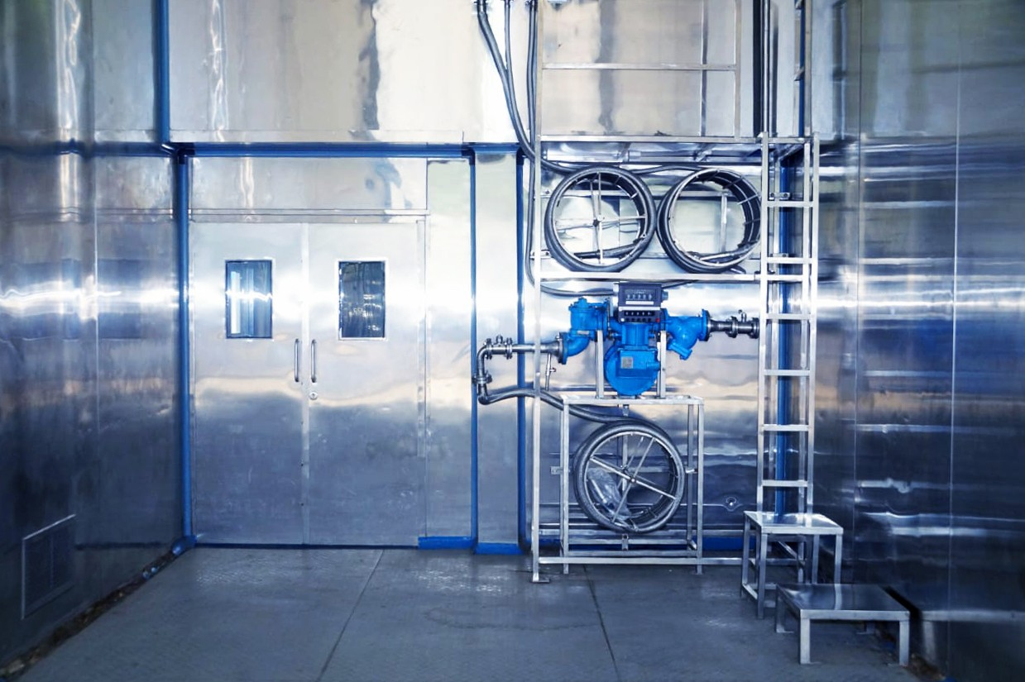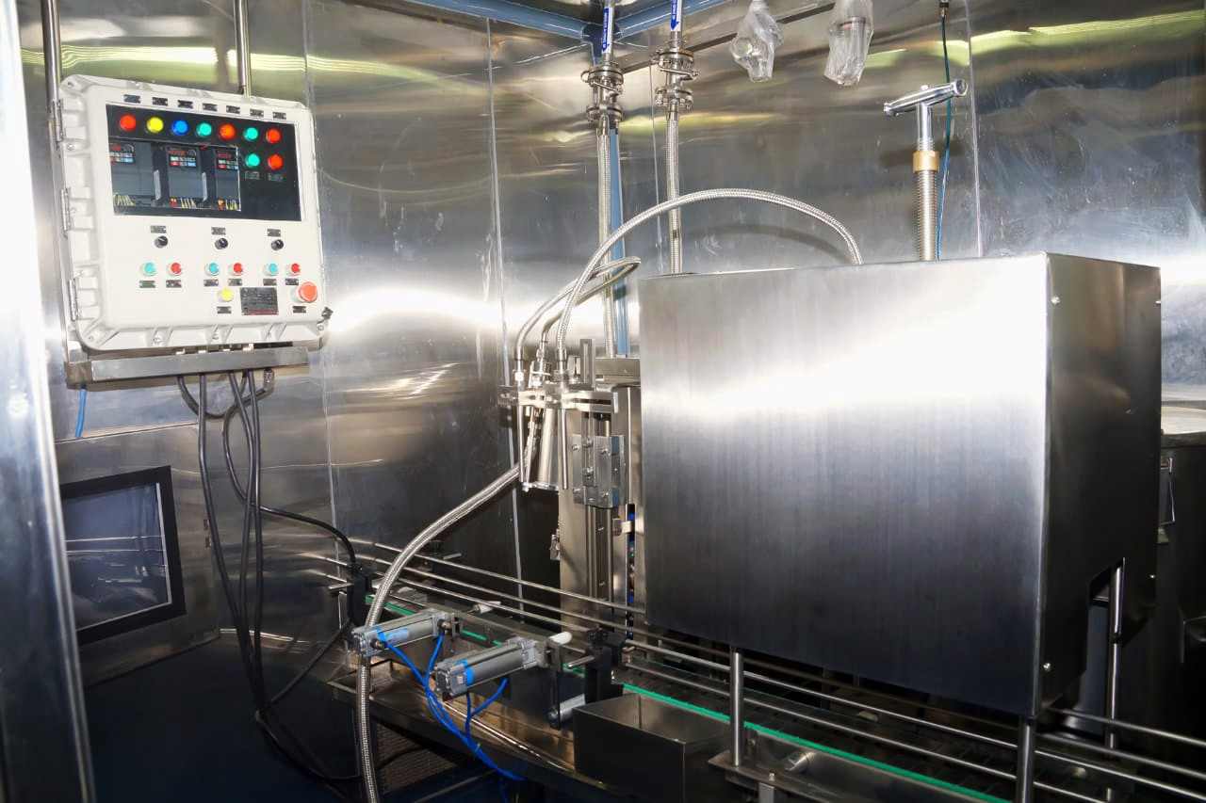

Plant

Karad, Maharashtra

MFG Process, Lab Details, Warehouse

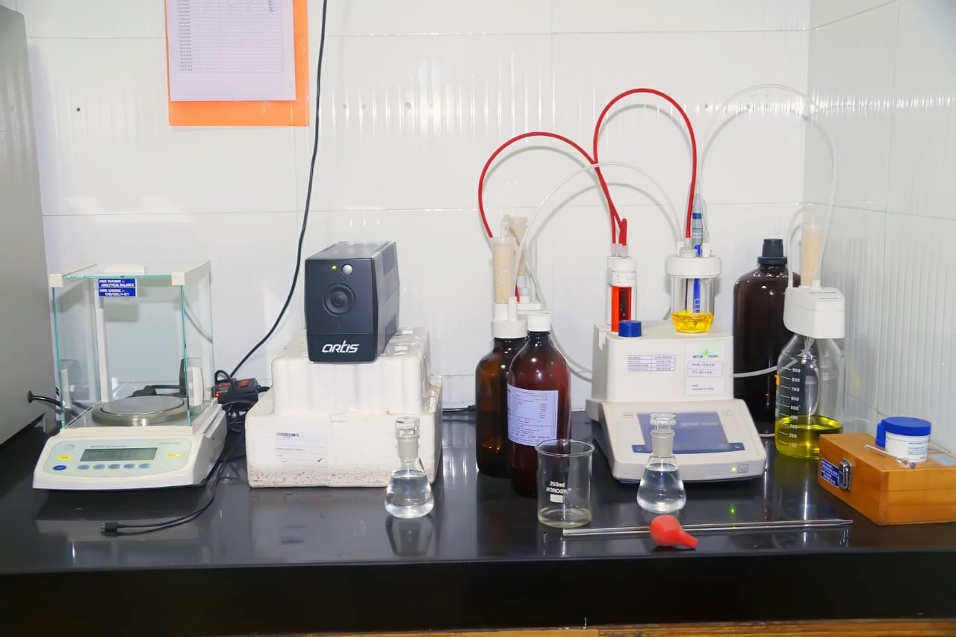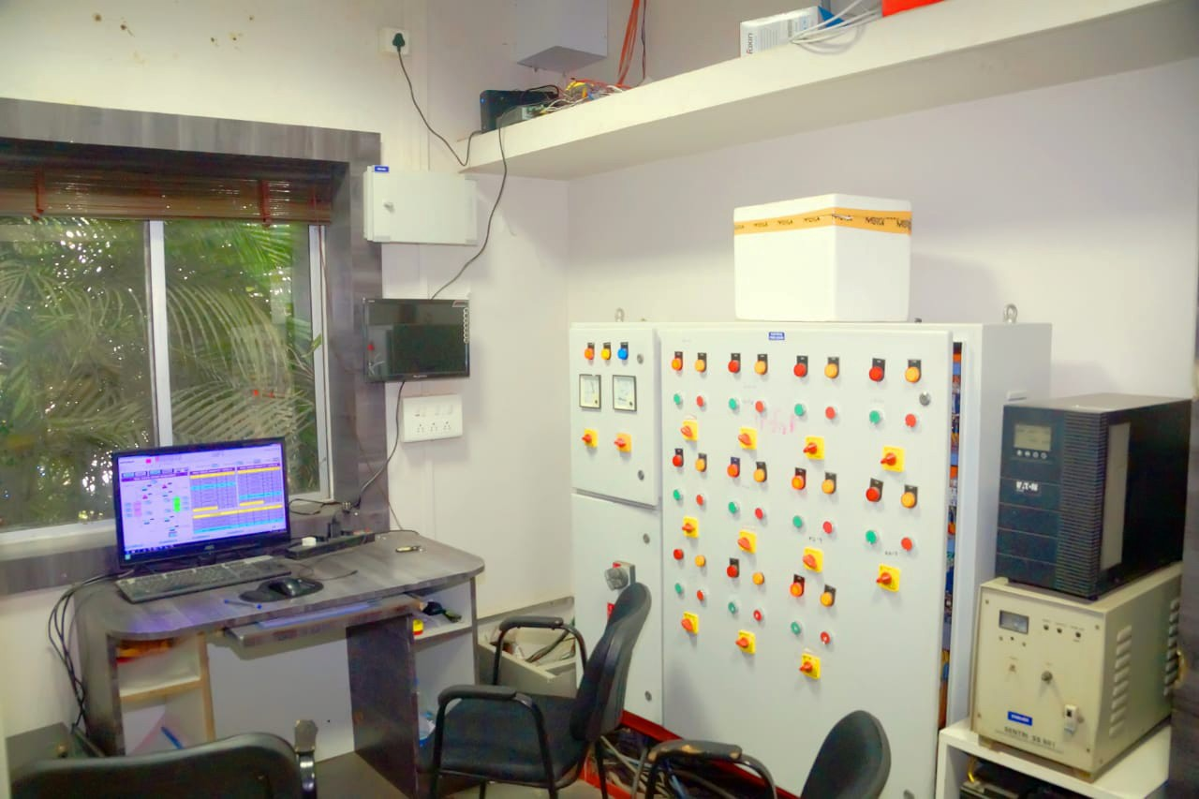

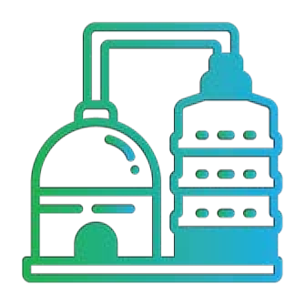
Machineries

Sr. No. | Name of Machinery | Make | Capacity
1 | Day Feed Tank | Mega Engineering | 1000BL
2 | Distillation Column | Disti Chemi | 15 KL
3 | Condenser | Mega Engineering | 300BL
4 | Super Heater | Mega Engineering | 300B
5 | Regeneration Beds | Mega Engineering | 15KL
6 | Product Condenser | Mega Engineering | 200BL
7 | Daily Product Tanks | Mega Engineering | 1000BL
8 | Raw Material Storage Tanks | Mega Engineering | 2 Tanks 289558BL
9 | Finished Product Storage Tank | Mega Engineering | 3 Tanks 442781BL
10 | Boiler | Rakhoh | 1 Ton
11 | Cooling Tower | Dew Pond Engineers | 12000LPH
12 | Generator | Kirloskar | 100KVA

Machineries

Sr. No. | Name of Machinery | Make | Capacity
13 | Generator | Kirloskar | 100KVA
14 | AHU’s | Fedders Lloyd Corporation | Velocity 8.8M/S & 8.7 M/S
15 | Air Curtains | Jet | Velocity 13.4M/S
16 | Bottling Machine | Pratik Enterprises | 360 Bottles Per Hour
17 | Filling Station | Vermont Technologies | 12000LPH
18 | PLC Controls | CIC Pvt. Ltd.
19 | Pumps and Motors | SPX Johnson Pumps
20 | Filters | Crompton Greaves Ltd. | All Motors 100HP



Laboratory Instruments


Warehouse
Baddi & Goa

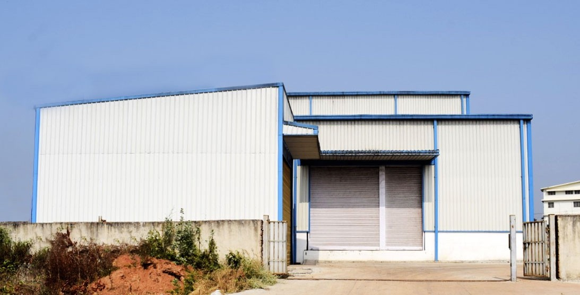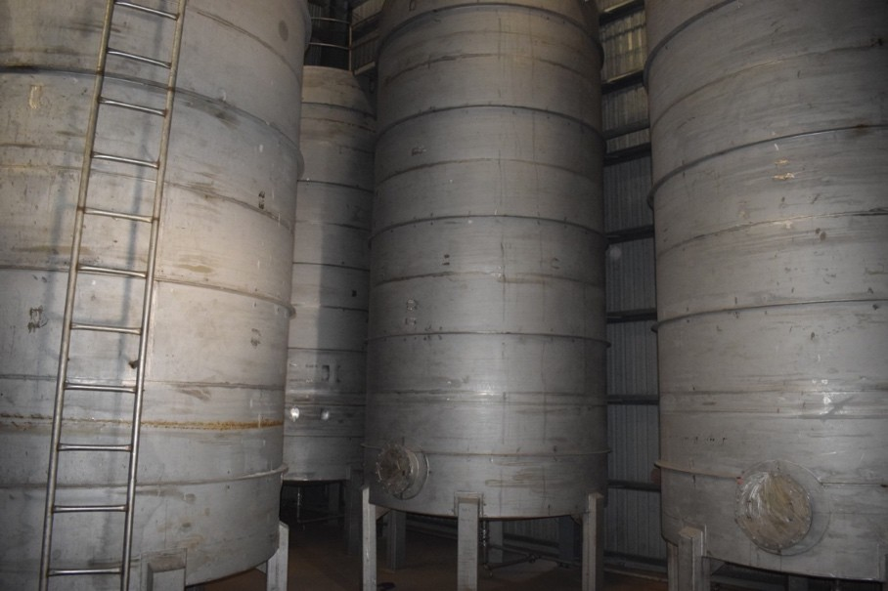
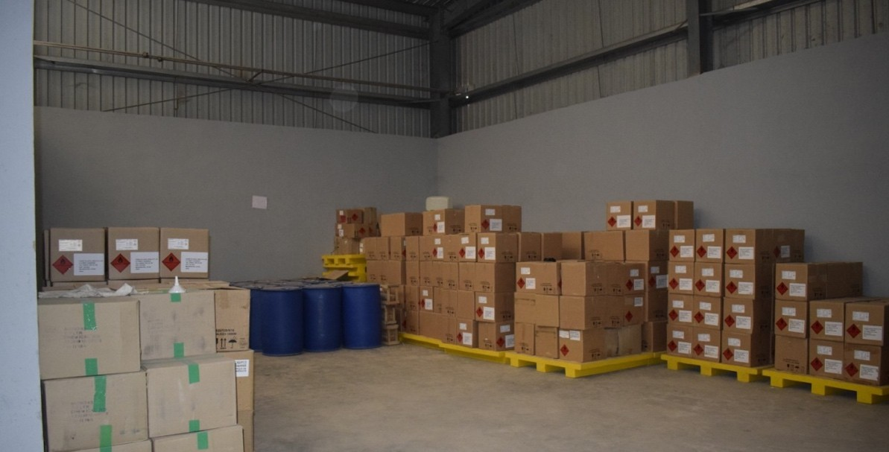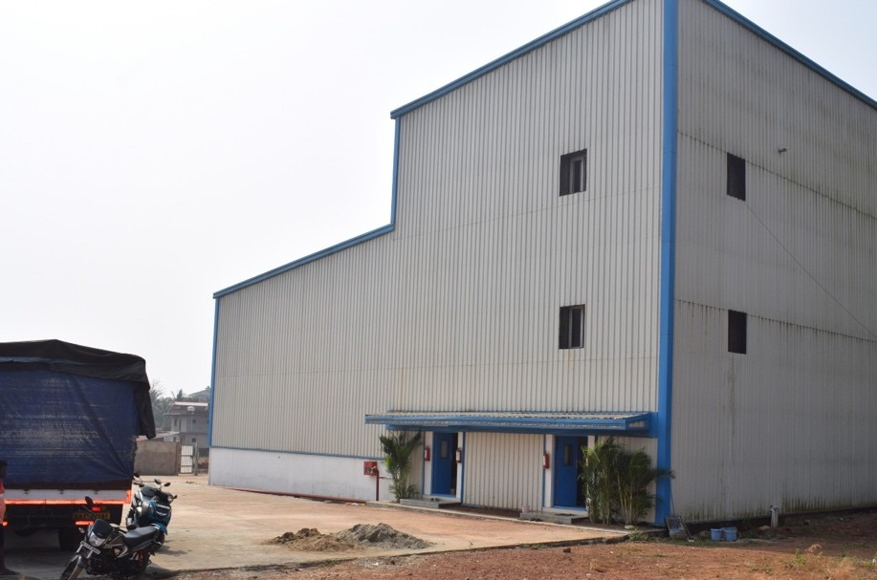


Distribution System
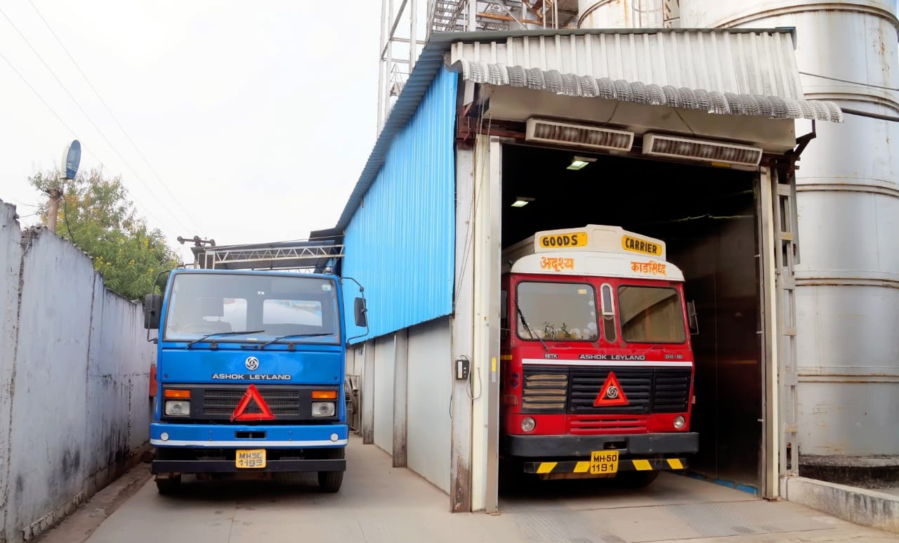


Clientele



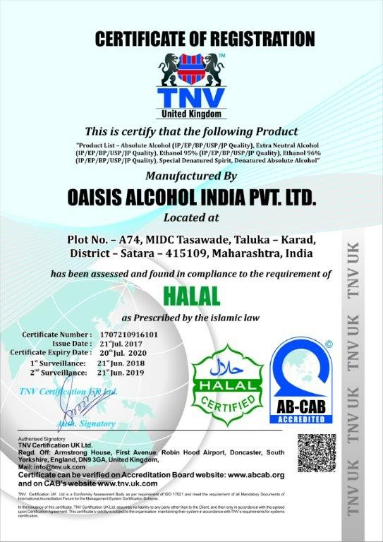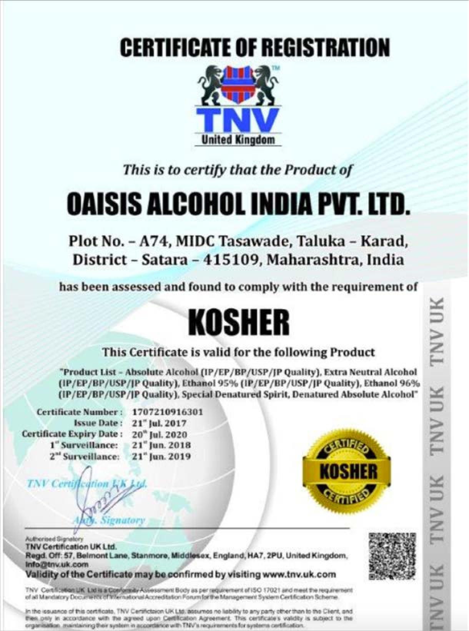


Licenses

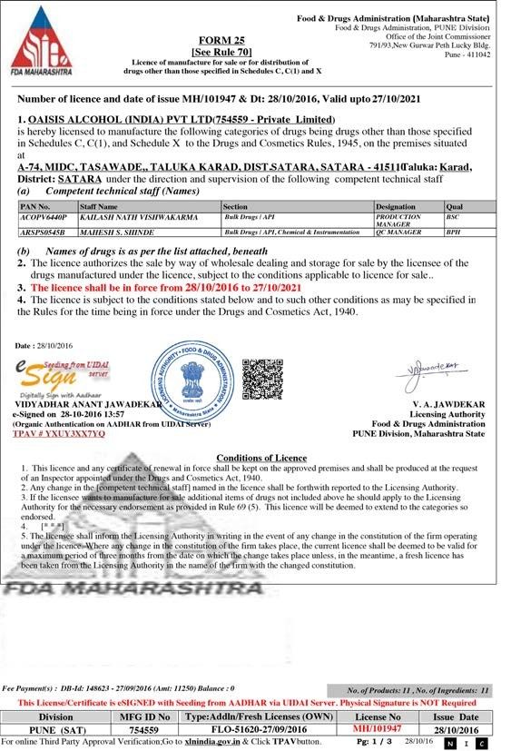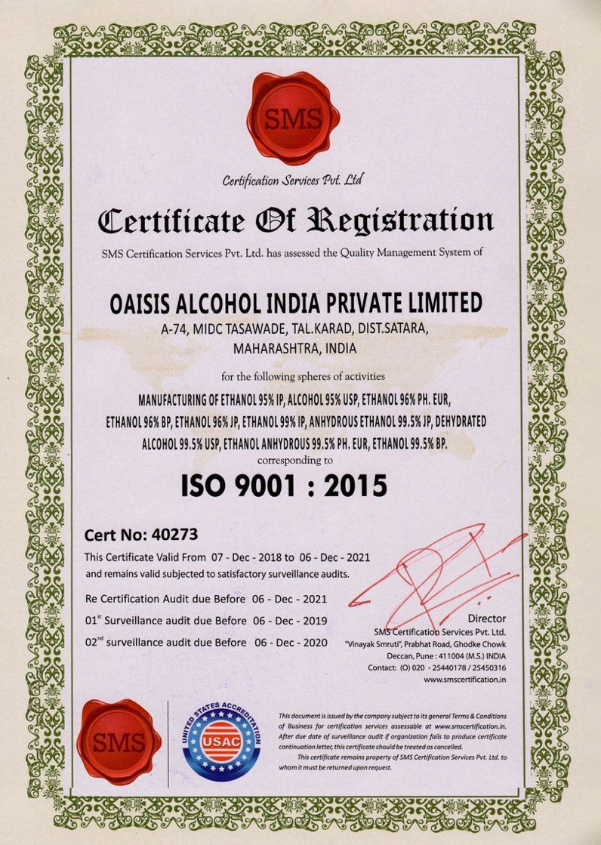
Licenses

Thank You

Head Office Factory

